**HandsMen Threads: Elevating the Art of Sophistication in Men's Fashion - Salesforce Project Documentation**

**Abstract**

The "HandsMen Threads" Salesforce project is a strategic initiative for a dynamic organization in the fashion industry, aimed at transforming its data management practices and significantly enhancing customer relations. This project focuses on establishing a robust, scalable data model within the Salesforce platform to centralize all critical business data, ensuring a seamless and consistent flow of information across various departments. A core tenet of this implementation is the emphasis on maintaining data integrity directly from the user interface (UI), safeguarding the accuracy and reliability of information essential for informed decision-making and efficient business operations.

Beyond data consolidation, the project integrates several automated processes into the existing business workflow. These include automated order confirmations to boost customer engagement, a dynamic loyalty program that adapts to purchase history for personalized rewards, proactive stock alerts to prevent inventory shortages, and scheduled bulk order updates to maintain accurate financial and inventory records. By leveraging Salesforce's powerful capabilities, HandsMen Threads seeks to improve customer service, optimize operational efficiency, and foster stronger, more personalized customer relationships.

**Object (Salesforce Data Model)**

The foundation of the HandsMen Threads Salesforce solution is a meticulously designed data model comprising standard and custom objects. These objects are structured to capture and manage all pertinent business data, ensuring a holistic view of customers, products, orders, and inventory.

Key Objects include:

* **Customer/Contact:** (Likely a combination of standard Contact or a custom Customer__c object) Stores detailed information about individual customers, including contact details, preferences, and historical interactions. This object serves as the central hub for all customer-centric activities.
* **Order:** (Custom Order__c object, potentially linked to standard Order functionality if applicable) Represents a customer's purchase. It captures details such as order date, total amount, status, and links to the customer and the products ordered.
* **Product:** (Standard Product2 object) Manages the catalog of fashion items offered by HandsMen Threads. It stores product names, descriptions, pricing, stock-keeping units (SKUs), and links to inventory levels.
* **Inventory/Stock:** (Custom Inventory__c object, potentially related to Product2) Tracks the current stock levels of each product. This object is crucial for managing availability and triggering reorder alerts.
* **Loyalty Status:** (Custom Loyalty_Status__c object or fields on Contact/Customer__c) Defines and tracks the loyalty tier of each customer (e.g., Bronze, Silver, Gold, Platinum). This object or fields are dynamically updated based on purchase history.
* **Financial Record:** (Custom Financial_Record__c object) Used to log and manage financial transactions related to bulk orders and other business operations, ensuring accurate accounting and reconciliation.

These objects are interconnected through various lookup and master-detail relationships, creating a comprehensive and navigable data structure that supports all business processes.

**Technology Description**

The HandsMen Threads project leverages the robust and versatile capabilities of the Salesforce platform, utilizing a combination of declarative tools and programmatic development to meet the project's requirements.

* **Salesforce Platform:** As a leading cloud-based Customer Relationship Management (CRM) platform, Salesforce provides the secure, scalable, and customizable environment for managing customer data, sales, service, and marketing operations.
* **Data Modelling:** Custom Objects, Fields, and Relationships are extensively used to build the tailored data structure required by HandsMen Threads. This includes defining custom fields for specific business attributes and establishing relationships (Lookup, Master-Detail) between objects to ensure data integrity and facilitate reporting.
* **Data Quality:** To safeguard data accuracy and consistency from the UI, Salesforce's native data quality features are employed. This includes:
  + **Validation Rules:** Enforcing specific criteria for data entry, preventing incorrect or incomplete information from being saved.
  + **Duplicate Rules:** Identifying and optionally blocking duplicate records to maintain a clean and reliable database.
* **Lightning App Builder:** This declarative tool is used to create intuitive and efficient user interfaces. Custom Lightning Apps provide a tailored navigation experience for different user roles, while customized Lightning Record Pages ensure that users see relevant information and actions for each record type, enhancing user productivity.
* **Record-Triggered Flows:** Salesforce Flows are a powerful automation tool used to implement the majority of the project's automated processes. Record-Triggered Flows are specifically used for:
  + **Automated Order Confirmations:** Triggered upon order creation/update to send email notifications to customers.
  + **Dynamic Loyalty Program:** Triggered by order completion or specific purchase milestones to update customer loyalty statuses.
  + **Proactive Stock Alerts:** Triggered when Inventory records indicate stock levels dropping below a predefined threshold (e.g., five units) to notify the warehouse team.
* **Apex and Apex Triggers:** For complex business logic that cannot be achieved declaratively with Flows, Apex (Salesforce's proprietary programming language) and Apex Triggers are utilized. Triggers are executed before or after specific data manipulation language (DML) events (e.g., insert, update, delete) on records.
* **Asynchronous Apex:** Specifically for the "Scheduled Bulk Order Updates," Asynchronous Apex, such as Scheduled Apex or Batch Apex, is employed. This allows for the processing of large volumes of data outside of the immediate user transaction, preventing governor limit issues and ensuring efficient daily operations. Scheduled Apex is used to run the bulk update process at a specific time (e.g., daily midnight).

**Detailed Execution of Project Phases**

The HandsMen Threads Salesforce project followed a structured approach, moving through distinct phases to ensure successful implementation and adoption.

1. **Discovery and Requirements Analysis:** This initial phase involved in-depth discussions with HandsMen Threads stakeholders to thoroughly understand their existing business processes, pain points, and desired outcomes. Detailed requirements were documented for data management, customer service enhancements, and operational efficiencies.
2. **Data Model Design and Configuration:** Based on the gathered requirements, the Salesforce data model was designed. This involved identifying necessary custom objects (e.g., Order__c, Inventory__c, Loyalty_Status__c, Financial_Record__c), defining their fields, and establishing appropriate relationships to existing standard objects (e.g., Product2, Contact). Validation rules and duplicate rules were configured to enforce data integrity at the point of entry.
3. **User Interface (UI) Development with Lightning App Builder:** Custom Lightning Apps were created to provide tailored navigation for different user profiles within HandsMen Threads (e.g., Sales, Customer Service, Warehouse). Lightning Record Pages were designed for each key object, optimizing the layout, highlighting critical information, and embedding relevant components and actions to streamline user workflows.
4. **Automation Implementation with Flows:** The core real-time business processes were automated using Salesforce Record-Triggered Flows. This included building flows for sending automated order confirmation emails to customers, dynamically updating customer loyalty statuses based on their purchase history, and triggering email alerts to the warehouse team when product stock levels fall below a critical threshold.
5. **Custom Logic and Asynchronous Processing with Apex:** For more complex, scheduled, or high-volume operations, Apex code was developed. Specifically, Scheduled Apex was implemented to manage the daily midnight processing of bulk orders. This Apex job handles the intricate logic of updating financial records and adjusting inventory levels efficiently, ensuring accurate stock data for the next day's operations.
6. **Testing, Training, and Deployment:** Rigorous testing was conducted across all implemented features, including unit testing for Apex code, system integration testing for flows and data model interactions, and user acceptance testing (UAT) with key business users. Comprehensive training materials were developed, and training sessions were conducted for end-users. Finally, the solution was deployed to the production environment, followed by post-deployment support and monitoring.

**Project Explanation with Real-World Example**

Let's illustrate the project's impact with a real-world scenario at HandsMen Threads:

**Scenario: A Customer Places an Order, and Stock Levels are Low**

1. **Customer Places an Order:** A customer, "Mr. David Lee," visits the HandsMen Threads website and places an order for two "Classic Silk Ties."
2. **Order Creation & Data Integrity:** When the order is entered into Salesforce (either manually by a sales representative or via an integration), a new Order__c record is created. The system's validation rules ensure all necessary fields (e.g., customer details, product quantity) are accurately populated, maintaining data integrity from the UI.
3. **Automated Order Confirmation (Flow):** Immediately upon the order being saved and confirmed, a **Record-Triggered Flow** springs into action. This flow automatically sends a personalized order confirmation email to Mr. Lee, detailing his purchase, estimated delivery, and a thank you message. This proactive communication enhances customer satisfaction and engagement.
4. **Dynamic Loyalty Program Update (Flow):** Concurrently, another **Record-Triggered Flow** evaluates Mr. Lee's purchase. If this purchase pushes his total spending over a certain threshold, the flow automatically updates his Loyalty_Status__c from "Silver" to "Gold." This change might trigger a welcome email to his new tier, offering exclusive discounts for future purchases, fostering repeat business.
5. **Inventory Adjustment:** The Inventory__c record for "Classic Silk Ties" is updated to reflect the two units sold.
6. **Proactive Stock Alert (Flow):** As the inventory for "Classic Silk Ties" drops, let's say it falls below five units (the predefined threshold). A **Record-Triggered Flow** detects this change. This flow then automatically sends an email notification to the warehouse team, alerting them that "Classic Silk Ties" are running low and prompting them to initiate a reorder. This prevents stockouts and ensures product availability.
7. **Scheduled Bulk Order Update (Asynchronous Apex):** At midnight, the Scheduled Apex job runs. This job processes all bulk orders placed throughout the day. It systematically updates the Financial_Record__c objects with the aggregated financial data from these bulk orders and makes any necessary large-scale adjustments to Inventory__c for other high-volume items. This ensures that financial records are always up-to-date and inventory counts are accurate for the start of the next business day.

This example demonstrates how the integrated Salesforce solution provides a seamless experience for customers, automates critical internal processes, and ensures data accuracy, ultimately contributing to HandsMen Threads' operational excellence and customer satisfaction.

**Screenshots:**

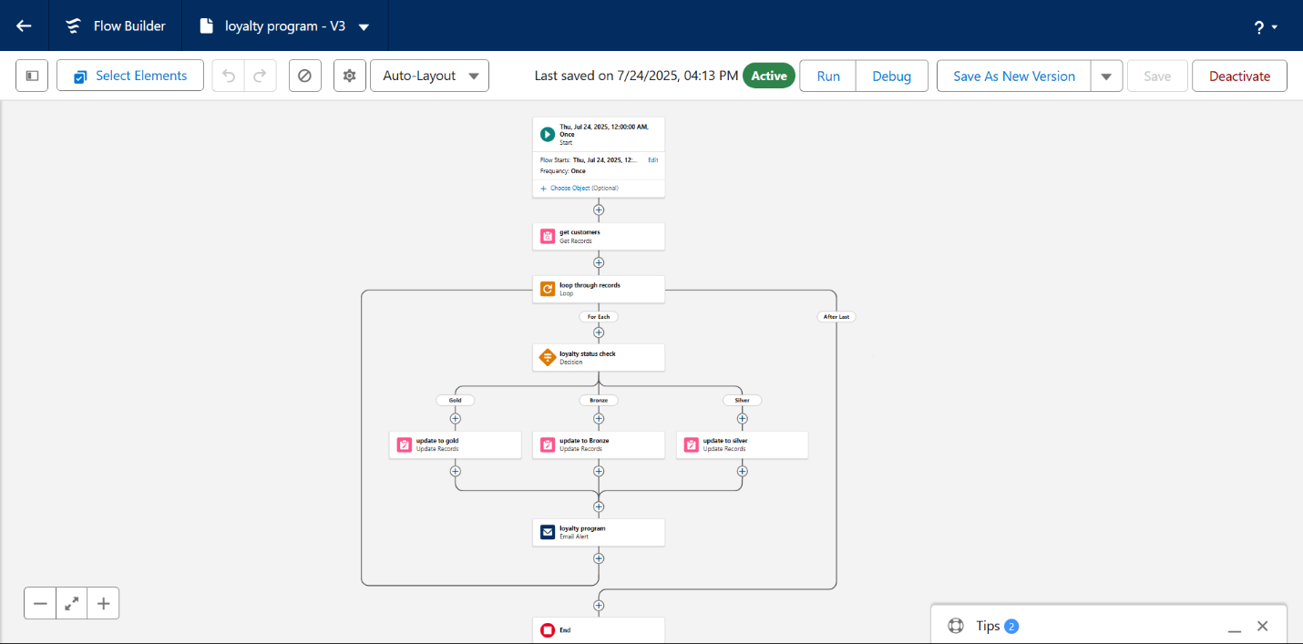

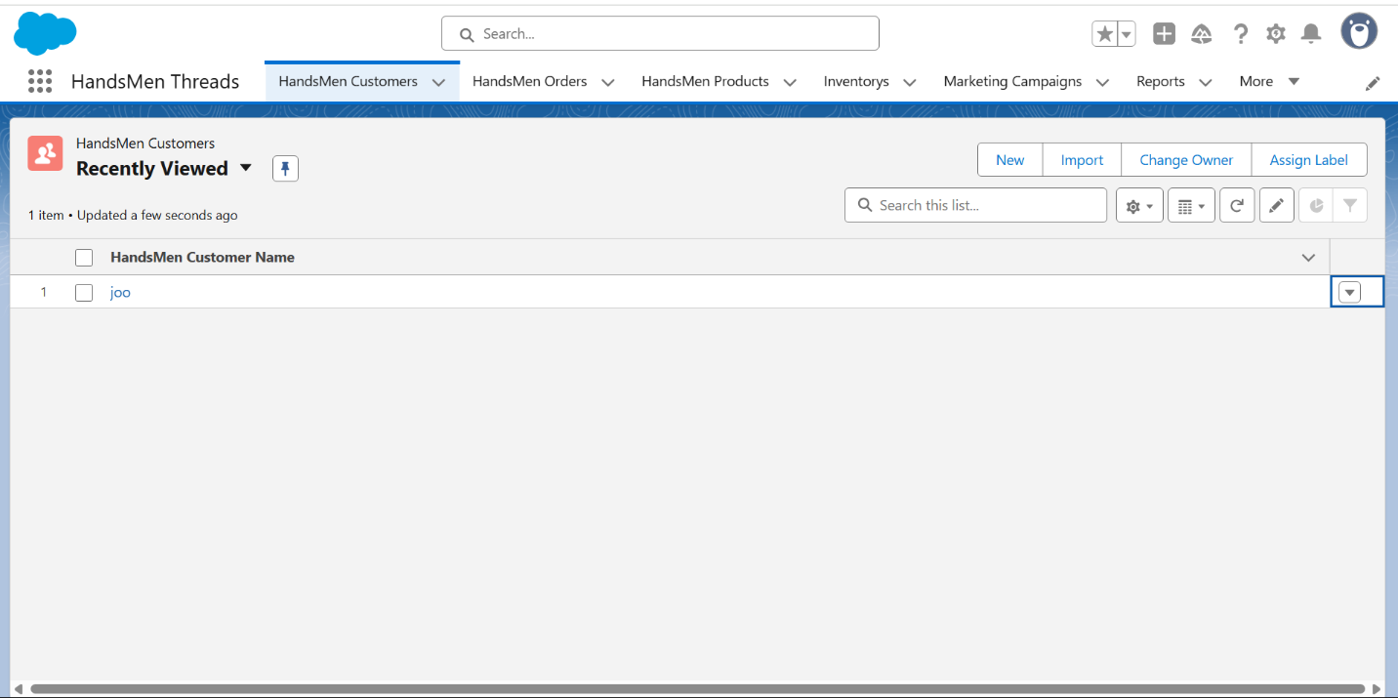

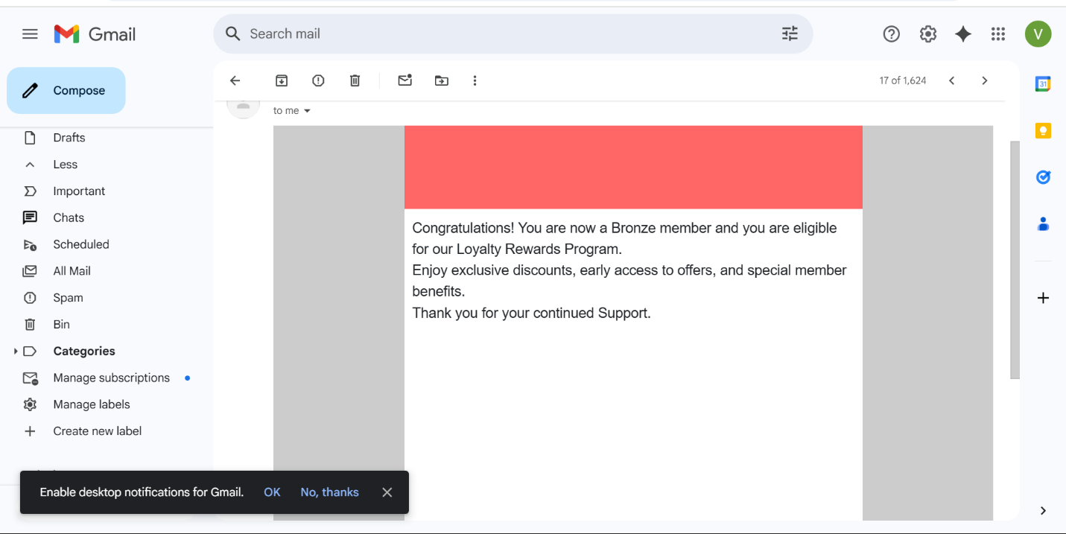

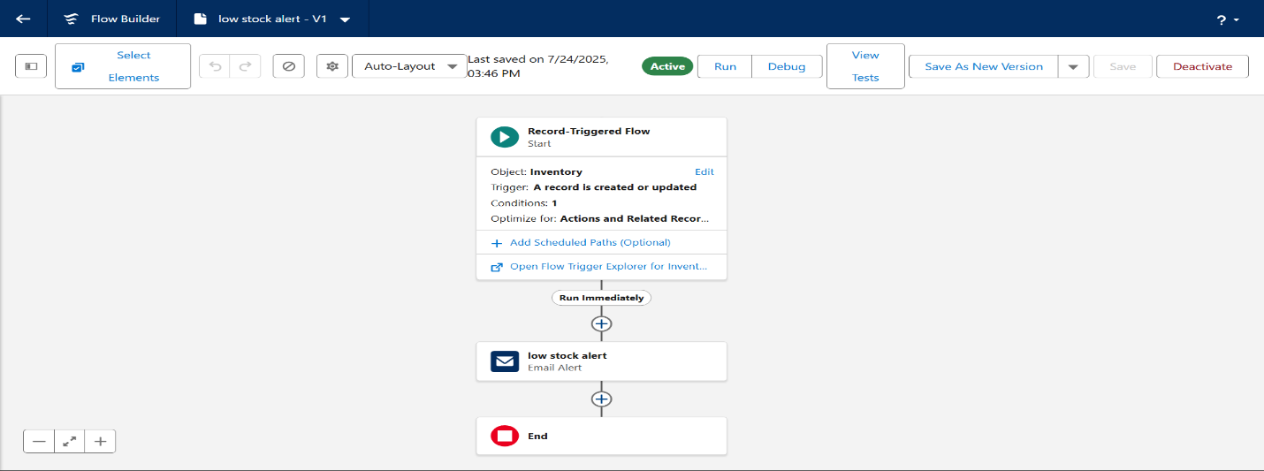

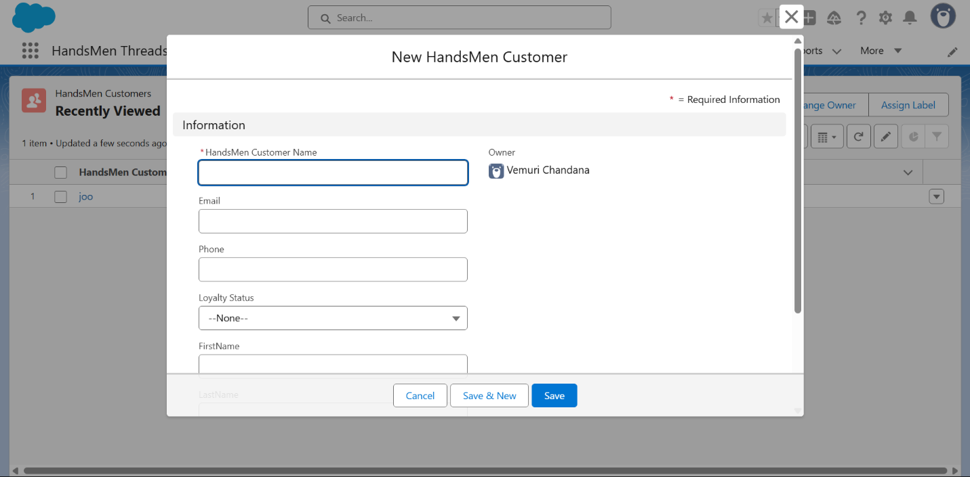

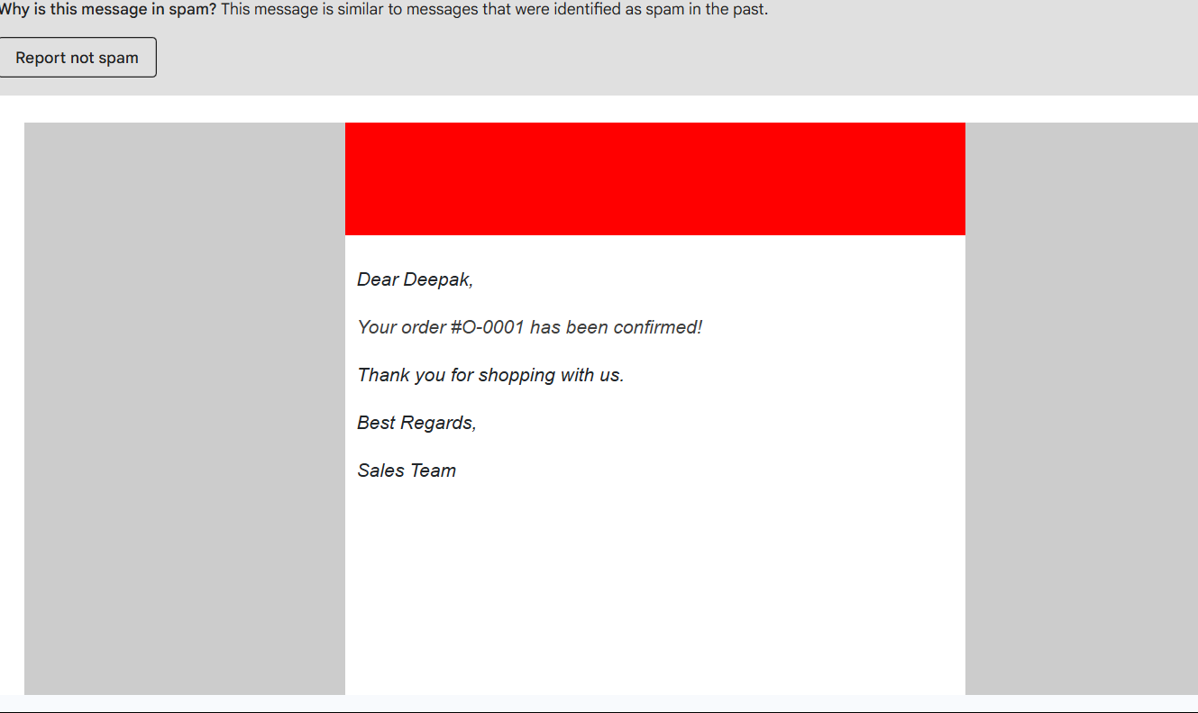

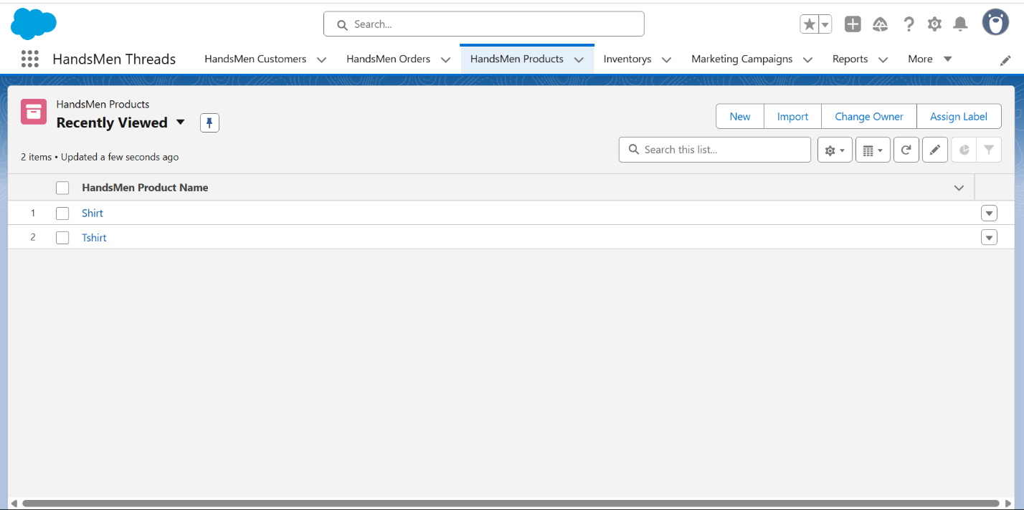

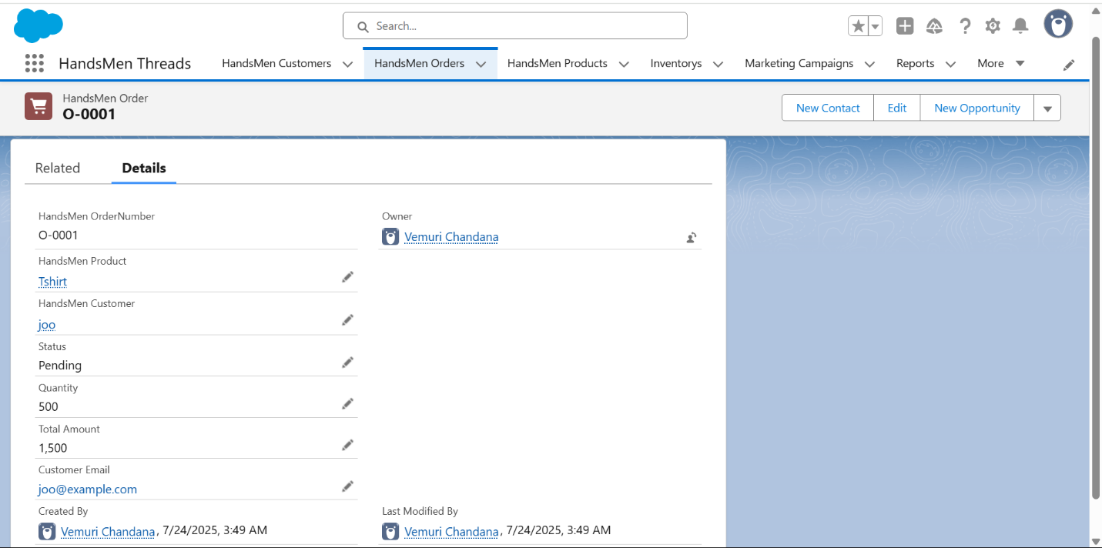

**Conclusion**

The "HandsMen Threads" Salesforce project successfully establishes a robust and efficient platform for managing core business operations in the fashion industry. By implementing a tailored data model, enforcing data integrity, and automating key processes through Salesforce Flows and Apex, the project has significantly enhanced customer relations and operational efficiency. The automated order confirmations, dynamic loyalty program, proactive stock alerts, and scheduled bulk order updates collectively contribute to improved customer engagement, reduced manual effort, and more accurate data for informed decision-making. This foundational implementation positions HandsMen Threads for sustained growth and superior customer service in a competitive market.

**Future Scope**

The current Salesforce implementation for HandsMen Threads lays a strong foundation, but there are several avenues for future expansion and enhancement:

1. **Integration with External Systems:**
   * **ERP Integration:** Integrate Salesforce with an Enterprise Resource Planning (ERP) system for seamless financial management, supply chain optimization, and comprehensive inventory control beyond just stock alerts.
   * **Marketing Automation Platform:** Connect with platforms like Marketing Cloud or Pardot to enable more sophisticated customer segmentation, personalized marketing campaigns, and lead nurturing.
   * **E-commerce Platform:** Deep integration with the e-commerce website to automate order creation, customer data synchronization, and real-time inventory updates.
2. **Customer Self-Service Portal (Experience Cloud):**
   * Develop a Salesforce Experience Cloud portal where customers can track their orders, view loyalty status, update their profiles, and access FAQs, reducing the load on customer service.
3. **Advanced Analytics and Reporting:**
   * Implement more sophisticated dashboards and reports using Salesforce Reports & Dashboards, CRM Analytics (formerly Tableau CRM), or integrate with external Business Intelligence (BI) tools for deeper insights into sales trends, customer behavior, and operational performance.
4. **AI and Predictive Capabilities (Einstein):**
   * Leverage Salesforce Einstein capabilities (e.g., Einstein Prediction Builder, Einstein Next Best Action) to predict customer churn, recommend personalized products, or suggest optimal stock reorder points based on historical data.
5. **Mobile App Development:**
   * Develop a dedicated mobile application for sales representatives or warehouse staff to manage orders, inventory, and customer interactions on the go.
6. **Enhanced UI/UX:**
   * Continuously refine the Lightning App and Record Pages based on user feedback to further optimize workflows and improve the overall user experience.
7. **Supplier Management:**
   * Extend the data model to include supplier information and manage procurement processes directly within Salesforce.